HAZARD CONTROL PROCEDURES

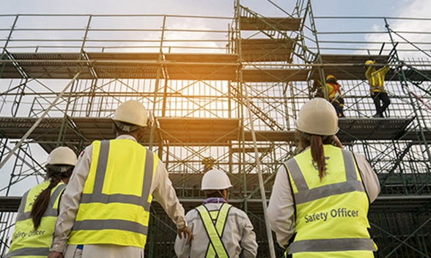
MODULE C
Module B is about:
- Hazard control procedures
- Selection of controls
- Identifying hazards

Module B includes:
- Content Overview
- Multiple Choice Quiz
- Short Answer Quiz
- Practice activity
- ‘What you should know’ Checklist

Word List
- Procedures
- Hierarchy
- Scaffold system
- Elimination
- Substitution
- Barricades
- Isolated
- General public
- Respirators
- Clean-shaven

Hazard Control Procedures
- Once the hazard has been identified and its potential to do damage is measured, the hazard needs to be controlled.
- It can be controlled in a few different ways
- Usually, more than one control method we will used to control a hazard.
- Various methods should be considered for the preference of controlling hazards by using the ‘Hierarchy of hazard controls’ (Figure 1).
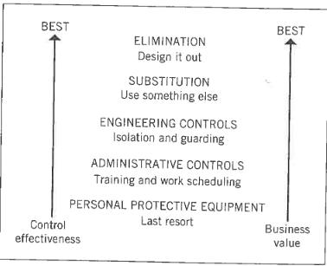
Figure 1: Hierarchy of hazard controls
SELECTION OF CONTROLS
- From Figure 1, you can see that there are 5 possible selections to control a hazard, with Elimination being the best control and Personal Protective Equipment (PPE) being the last resort.

- Elimination
- A common method of risk elimination is to reduce the amount of work being carried out. An example is reducing the amount of work carried out at height on ladders. By using an approved scaffold system workers are able to carry out a task without falling.

- Substitution
- Substitution occurs when hazardous material is replaced by a safer, less hazardous or non-hazardous material.
- An example is the substitution of asbestos cement sheeting and other asbestos containing materials (ACMs) by less hazardous fibre cement sheeting.

- Engineering Controls
- Engineering controls are devices or mechanisms built into the design or equipment or are part of the safety process. They are effective measures built into things like tools, equipment, fences and barricades.
- Tools and Equipment
- A guard on a power tool, static machine or aby equipment with a moving blade is a form of protective equipment – and engineering control on a hazard. The guard prevents material and/or material waste from being projected towards the operator, as well as preventing fingers or hands from being drawn to moving parts or blades. A guard is fitted as the last line of protection for an operator and therefore, should never be removed or tied back while the tool or machine is in use.
- Many portable hand-held power tools and static machines have guards fitted (Figure 2).
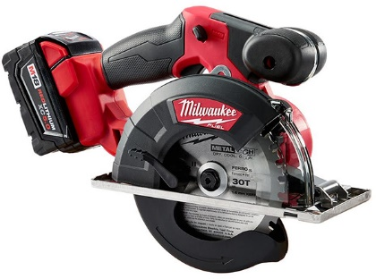
Figure 2: Circular saw fitted with a guard
- Fencing and barricades
- Before starting any work the area needs to be isolated to stop other workers and/or the general public from entering into the work area. You can do this by using temporary fencing or physical barricades.

- Administrative Controls
- This is achieved by correct planning. An example is, do not have the roof tiler working on the job at the same time as the bricklayer. Why? Because if a tiler drops a tile onto the head of a bricklayer there is an accident – or even a death – on site. This is an example of good administrative control by getting certain workers to work at different times.

- Personal Protective Equipment (PPE) and clothing
- PPE, as shown in Figure 1 is the last resort of hazard control to protect your health and safety in the workplace.
- It is the persons conducting a business or undertaking (PCBUs)/employer’s responsibility to provide the PPE, clothing and training to protect the worker. It is YOUR responsibility to wear and look after the equipment provided.
- To assess PPE requirements, the following needs to be considered:
- The workplace: could it be made safer so that you don’t need the PPE?
- PPE selection: is the PPE designed to provide adequate protection against the hazards at your workplace?
- PPE comfort and fit: is it comfortable? For example, close-fitting respirators give protection only if the person is clean-shaven. People with a beard or a ‘few-days growth’ will need to use a hood, helmet or visor-type respirator.
- PPE can be grouped according to the part of the body it will protect:
- Head – safety helmets and sun hats
- Eyes/face – safety spectacles, goggles, face shields
- Hearing – ear muffs, ear plugs
- Airways/lungs – dust masks, respirators
- Hands – gloves, barrier creams
- Feet – safety boots and shoes, rubber boots
- Body – clothing to protect from sun, cuts, abrasions and burns; high visibility safety garments and fall protection harness.
IDENTIFY HAZARD
- To decide what PPE and clothing is required, you must first be able to identify the hazard involved. The types of hazards commonly identified with PPE and clothing are:
- Physical hazards – noise, thermal, vibration, repetitive strain injury (RSI), manual and radiation hazards
- Chemical hazards – dusts, fumes, solids, liquids, mists, gases and vapours
- Once the hazard has been identified, suitable equipment and clothing must be selected to give maximum protection.

SOME EXAMPLES OF PPE AND CLOTHING
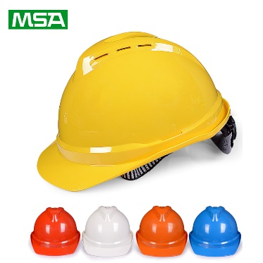 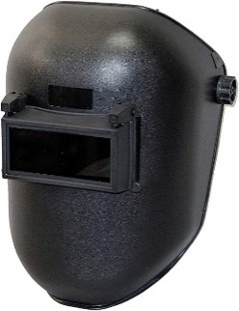 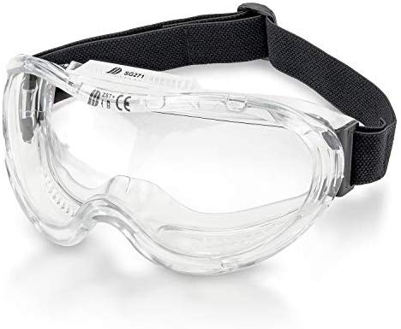 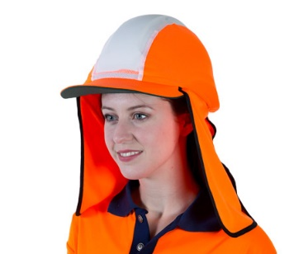 Safety Helmet Full-face welding mask Wide-vision goggles Safety helmet –with sun brim
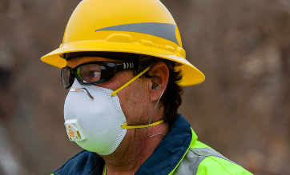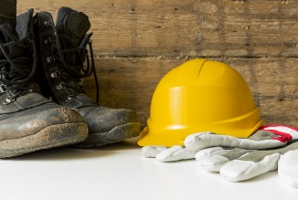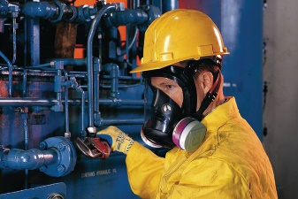
Disposable Masks Hearing Protection Foot protection Half-face respirator
MULTIPLE CHOICE QUIZ

- What is PCBU?

- Person conducting a business or undertaking

- People conducting a business or undertaking

- Public conducting a business or undertaking

- What is PPE?

- Persons Protective Equipment

- Personal Protective Equipment

- Personal Protective Equipped

- How many ‘Hierarchy of hazard controls’ are there?

- 6

- 7

- 5

- How many hazard categories are there?

- 7

- 5

SHORT ANSWER QUIZ

Please briefly answer the following questions:

- What are 5 possible selections to control a hazard from best to last resort?

- Describe what an engineering control is.

- What is an example of an administrative control?

- What do you need to consider for PPE requirements?

PRACTICE ACTIVITY

- In pairs, discuss examples (on a work site/construction context) of the five ‘Hierarchy of Hazard Controls’, including any PPE and clothing that you may need.
(For example: When at a work site to build a new house, we can ELIMINATE the hazard of falling and hurting ourselves by using a scaffolding system or reducing the amount of time on a ladder.)

- Write down these examples

- Take about 10 to 15 minutes to discuss and write this down

- Once finished, discuss your answers as a class.

‘What you should know’ Checklist

By Module C:
- You should know what legislation and regulation covers WHS

- You should know what regulating authority covers work safety in Tasmania

- You should know what is the role of codes of practice and guidelines

- You should know why the WHS laws were introduced

- You should know how to search of codes of practice

- You should know what a hazard is

- You should know how to make a risk assessment

- You should know how to use the risk matrix diagram

- You should know the hazard categories

- You should know common workplace hazards

- You should know what a hazard is

- You should know hazard control procedures

- You should know selection of controls

- You should know the different types of PPE and clothing

- You should know how to identify hazards

