HAZARDS AND RISKS
MODULE B
Module B is about:
- Workplace Hazards
- Hazard Categories

Module B includes:
- Content Overview
- Multiple Choice Quiz
- Short Answer Quiz
- Practice activity
- ‘What you should know’ Checklist

Word List
- Hazards
- Acute Hazards
- Chronic Hazards
- Risk
- Incident/Accident
- Assessment
- Matrix
- Foreign objects
- Negligible
- Rare
- Moderate
- Biological
- Ergonomic
- Psychosocial
- Microorganisms

CONTENT OVERVIEW

IDENTIFYING, ASSESSING AND CONTROLLING RISKS AND HAZARDS
- It is important to be able to identify workplace hazards and risks
- The building industry can have hazards and risks ranging from collapsing trenches, chemicals, noise and dust inhalation to back problems and other strains and sprains
HAZARDS
- Hazards can include objects in the workplace, such as machinery or chemicals
- Hazards can also be work processes where manual handling, excessive noise and fatigue may cause long-term damage
- There are TWO (2) categories of hazards:
- acute and
- chronic
- There is a process for reducing incidents and accidents by first rating the level of risk through a risk assessment process.
- The most common way of to do a risk assessment is to follow the risk matrix below (Figure 1). *You will do this in the practice activity.
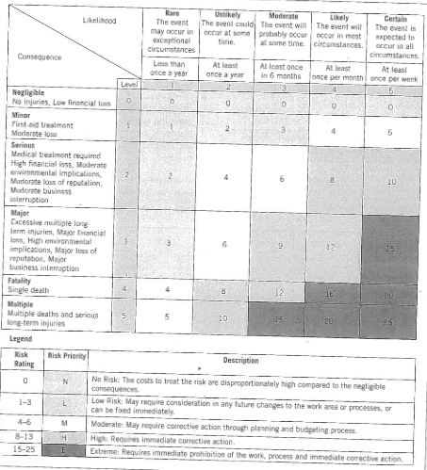
Figure 1: Risk Matrix Diagram
WORKPLACE HAZARDS

- Common hazards in the workplace that influence health and safety are:
- Lifting and handling materials
- Falls – of objects and people
- Machinery – power and hand tools
- Chemicals and airborne dust
- Noise
- Vibration
- Thermal discomfort (too hot or cold)
- Illumination (visibility)
- Fire and explosions

HAZARD CATEGORIES
- Hazards in the workplace are divided into five distinct categories:
- Biological
- Insect/animal
- Microorganisms

- Physical
- Noise
- Heat and cold
- Vibration
- Manual handling
- Electricity
- Airborne materials
- Heavy equipment
- Sharp materials

- Chemical
- Solids
- Liquids
- Gases
- Toxic chemicals

- Ergonomic
- confined spaces
- hand tools
- electrical tools

- Psychosocial
- drugs and alcohol
- bullying in the workplace
- work-related mental stress

- The reason hazards are divided into five major groupings is so that the correct and suitable control measures can be implemented to provide workers with the correct level of protection (Figure 2).
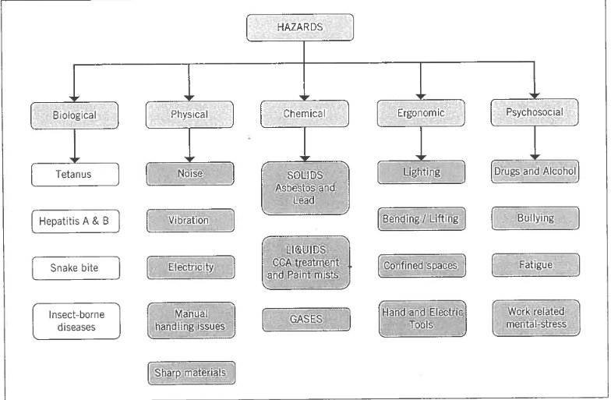
Figure 2: Hazard categories and subgroups

MULTIPLE CHOICE QUIZ

- How many categories of hazards are there?

- 3

- 5

- 2

- What is the process used to reduce incidents and accidents?

(a) Assessment Risk process

- Risk Assessment process

- Accessed Risk Process

- What do you have to follow to do a risk assessment?

- Matrix Risk

- Risked Matrix

- Risk Matrix

- How many hazard categories are there?

- 7

- 5

SHORT ANSWER QUIZ

Please briefly answer the following questions:

- Why are hazards divided into five major groupings?

- If a risk rating is between 15-25, what is the risk priority and description?

- What are the five sub-groups under the category of physical hazard?

- What are six common hazards in the workplace?

PRACTICE ACTIVITY

Please look at Figure 1 (page 2), Risk Matrix Diagram. Use the risk matrix to plot the result of this situation in a real-life work context.

CONTEXT: On the job-site, the foreperson sets up the compound mitre saw on the floor and asks you to cut timber to length. Your approximate time on the saw will be 4 hours. You have had very little training on the saw and your visibility is impaired because you are squatting over the top of the saw. You are also very concerned about your back hurting all the time.

ASK YOURSELF: What are the hazards? Consider the following:
- Hearing damage
- Foreign objects being thrown into the eyes
- Back strain
- Breathing in timber dust
- Amputate a hand or fingers

YOUR TASK: Each of the above need to be considered using the risk matrix diagram. HOWEVER, for this task, please only consider that you may ‘Amputate a hand or finger.’

COMPLETE THE TASK by asking yourself the following questions, knowing the context above and asking the likelihood (of an event occurring) and consequence (of the event) using the risk matrix diagram:

- How serious will an accident be if you put your hand through the saw?
- How likely is an accident to occur?
- What corrective action could you take?

‘What you should know’ Checklist

By Module B:
- You should know what legislation and regulation covers WHS

- You should know what regulating authority covers work safety in Tasmania

- You should know what is the role of codes of practice and guidelines

- You should know why the WHS laws were introduced

- You should know how to search of codes of practice

- You should know what a hazard is

- You should know how to make a risk assessment

- You should know how to use the risk matrix diagram

- You should know the hazard categories

- You should know common workplace hazards

