THE ORIGINS OF WORK HEALTH AND SAFETY
MODULE A
Module A is about:
- The background of Work Health and Safety in Australia and Tasmania
- The beginnings of the Work Health and Safety legislation
- The current Work Health and Safety legislation
- Regulations, codes of practice and guidelines
- Construction induction training

Module A includes:
- Content Overview
- Multiple Choice Quiz
- Short Answer Quiz
- Practice activity
- ‘What you should know’ Checklist

Word List
- Act
- Regulation
- Legislation
- Code of Practice
- Compensation
- Risk
- Hazard
- Injury
- Guidelines
- Self-regulation
- Potential
- Mutual
- Cease
- Valid
- Jurisdiction
- Induction

CONTENT OVERVIEW

WORK RELATED INJURIES

- The Work-related traumatic injury fatalities, Australia (2013) shows that from 2003 till 2013, there were 2806 Australian deaths, which is about 255 per year from work-related accidents.
- From 2003 to 2013, 402 people died in the construction industry.
- Work health and safety (WHS) is an important issue in all workplaces
- Preventing accidents in industry is not just for experts but is an issue for EVERYONE including persons conducting a business or undertaking (PCBUs).

ABOUT THE LEGISLATION

- To understand why a law (legislation) was introduced, we have to understand the reasons behind it. There were five main reasons why the WHS laws were introduced:
- Self-regulation not working – letting organisations regulate their own WHS was not effective. Over 500 people nationally were dying each year.
- National and overseas legal developments – WHS legislation updated in line with international and national standards for the twentieth century
- Many workers not covered – WHS initially only covered approximately one-third of the workforce. Now, all workers are covered
- Too much legislation – Previously, in one State there were too many Acts, approximately 26 enforcing procedures relating to occupational/work health and safety
- Cost of Compensation - Billions of dollars spent on workplace compensation. WHS legislation was introduced together with worker’s compensation to provide for injured workers who were unable to work.
- Tasmania first introduced legislation in 1977. The NEW and CURRENT Act is the Work Health and Safety Act 2012.

CURRENT WHS LEGISLATION

- Industrial workplace in Australia is governed by:
- Federal and State legislation and
- Regulations and Codes of practice

IN TASMANIA: Table 1

Current WHS Act | Current WHS Regulation | WHS Regulating Authority | Website and contact
Work Health and Safety Act 2012 | Work Health and Safety Regulations 2012 | Work Safe Tasmania | https://www.worksafe.tas.gov.au/

REGULATIONS, CODES OF PRACTICE AND GUIDELINES

- Workplace hazards that have the POTENTIAL of causing injury or disease needs specific regulations or codes of practice too.
- These regulations and codes of practice are part of the State of Tasmania’s WHS Act.
- The role of the regulation and codes of practice is to explain the duties of particular groups of people so that risks associated with specific hazards can be controlled.
- The purpose of codes and guidelines is provide workers in different industries with practical, common sense, industry acceptable ways by which to work safely.
- Regulations are legally enforceable.
- Codes of practices and guidelines give advice on how to meeting the requirements of the regulation.
- Codes of practice are not legally enforceable, but can be used as evidence in court to show that a regulation has been met or has not been met.

PRATICAL USE OF A CODE OF PRACTICE

- Codes of practice are written by Safe Work Australia as ‘Model Codes of Practice.’
- From this model, each State and territory’s regulating authority (Work Safe Tasmania) adopts this code of practice in different areas, for example:
- Managing the risk of falls at workplaces
- How to safely remove asbestos

GENERAL CONSTRUCTION AND INDUCTION TRAINING

- The WHS Regulations 2011 (Commonwealth) says that workers in the construction industry have to finish a general induction training before they carry out construction work
- This general induction training teaches basic knowledge on construction work, the WHS laws, common hazards and how risks can be controlled
- On completion of the general induction training the worker will receive a card (Figure1) that gives:
- A statement outlining the training they received
- Identifies who trained them
- Identifies the assessor
- The date the training was completed
- The construction induction card will:
- Have your name on it
- The date you completed training
- A special number of the registered training organisation
- What State (TAS) you completed this training
- A unique number for you to say you have completed this training
- You must carry this card on-site at all times and produce it when asked
- The card can cease to be valid if you have not carried out construction work a certain period of time. For example 2 years. If so, you will have to do the induction training again.
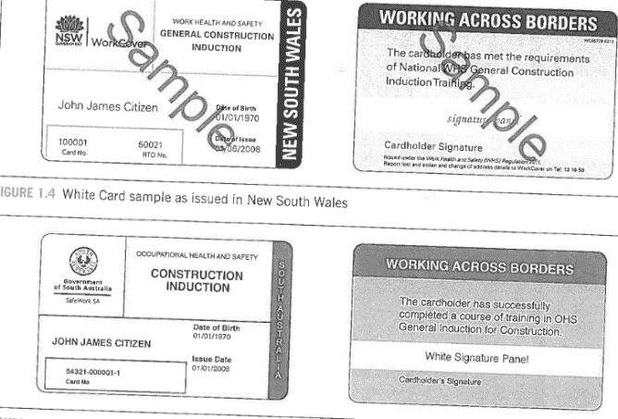
Figure 1: Construction Induction Card

MULTIPLE CHOICE QUIZ

- What does WHS mean?

- Workplace Healthy and Safety

- Work Health and Safe

- Work Health and Safety

- What is Tasmania’s WHS Act?

(a) Workplace Healthy and Safety Act 2002

- Work Health and Safe Act 2014

- Work Health and Safety Act 2012

- Who is the regulating authority for WHS?

- Workplace Tasmania

- Work Safe Hobart

- Work Safe Tasmania

- Are regulations legally enforceable?

- Yes

- No

- Are codes of practice legally enforceable?

- Yes

- No

SHORT ANSWER QUIZ

Please briefly answer the following questions:

- Workplace hazards have the potential of doing what?

- What is the role of regulations?

- What is the purpose of codes and guidelines?

- What are the fives reasons why WHS laws were introduced?

- Who governs industrial workplace in Australia?

- What training do have to complete before carrying out construction work? Please explain a little about the training.

PRACTICE ACTIVITY

Using the information in Table 1, visit the website of the regulating authority for Tasmania and search for: How to Safely Remove Asbestos Code of Practice Oct 2018 (PDF, 3.0MB).

Using this document, please answer the following questions:

- What type of licence is required to remove ‘any amount or quantity of asbestos or ACM, including: any amount of friable asbestos or ACM?’

- What type of licence ‘can remove: − any amount of non-friable asbestos or ACM?’

- In Tasmania, what is the maximum amount of non-friable asbestos or ACM that can be removed by someone with no licence?

‘What you should know’ Checklist

- You should know what legislation and regulation covers WHS

- You should know what regulating authority covers work safety in Tasmania

- You should know what is the role of codes of practice and guidelines

- You should know why the WHS laws were introduced

- You should know how to search of codes of practice

- You should know the process of construction induction training

